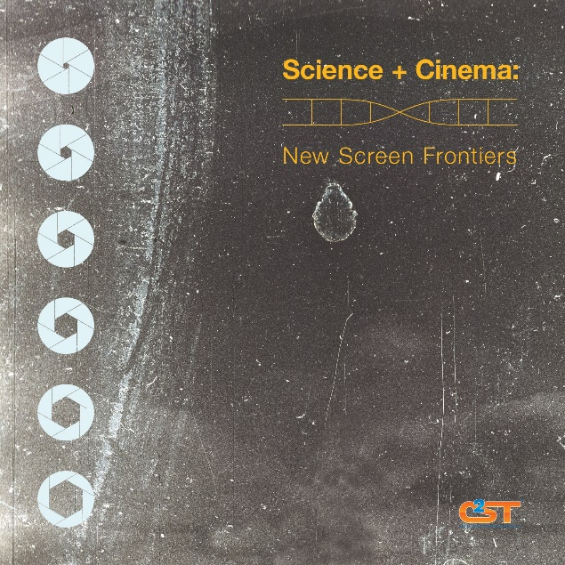
Science + Cinema: New Screen Frontiers

Outreach.

That necessary component of funding, communicating what it is we as scientists are doing to bring attention (and more research dollars) to support our work, our labs…

Film and documentaries are the perfect medium, a chance to tell your particular story in precise detail and living color. Learn how this can be done, meet area film makers who have worked on prize-winning science films, hear from scientist/film maker teams about their collaborations, and meet- and- greet with film makers looking for scientists to collaborate with on future projects.

The Chicago Council on Science and Technology and the Chicago International Film Festival, along with Columbia College Chicago, present a night discussing the representation of science in cinema and the collaborative process between scientists and film makers.

Discussion will be followed by a brainstorming session—a chance for scientists to share their own big-screen experiments, and network with potential collaborators.

This event is a kick-off for the Chicago International Film Festival’s new science film initiative, which will involve the introduction of special divisions in the 2015 Festival for narrative and documentary films with science- related themes.

FILM SELECTIONS TO BE BRIEFLY DISCUSSED:

Head Games by Steve James and Bruce Sheridan; Head Games The Film, LLC
Subject matter: sports concussion
Bruce Sheridan, professor & chair, Columbia College Chicago Cinema Art + Science, filmmaker
Peggy Mason, professor of neurology, The University of Chicago
Watch trailer: http://www.imdb.com/video/imdb/vi201106713/

Terra Incognita by Maria Finitzo; Kartemquin
Subject matter: stem cell research
Maria Finitzo, director / producer
John A Kessler, MD, the Ken & Ruth Davee professor of stem cell biology, Northwestern University
Watch trailer: http://www.kartemquin.com/films/mapping-stem-cell-research-terra-incognita/video/6227

The Believers by Clayton Brown and Monica Ross; 137 Films
Subject matter: cold fusion
Clayton Brown, executive director, director / producer, 137 Films
Monica Ross, artistic director, 137 Films
Mark Oreglia, professor in physics, The University of Chicago
Watch trailer: http://www.kartemquin.com/films/mapping-stem-cell-research-terra-incognita/video/6227

DETAILS:

Tuesday, October 21, 2014. Film Row Cinema, Columbia College Chicago. 1104 S. Wabash, 8th Floor. Check-in 6 p.m. Discussion with directors, scientists and short film clips: 6:30 p.m. Brainstorming Session 7:30 p.m. Networking 8:30 p.m. Free and open to the public, registration encouraged at: http://www.eventbrite.com/e/science-cinema-new-screen-frontiers-tickets-13263480427 Contact Andrea Poet at apoet@c2st.org or 312-567-5795 with any questions.

PARTNERS on this event include: The Chicago Council on Science and Technology, the Chicago International Film Festival, Columbia College Chicago Cinema Art + Science, University of Chicago, Northwestern University, Mayer Brown, 137 Films, and Kartemquin Films.

ABOUT C2ST: Chicago Council on Science and Technology is a not-for-profit, membership-based organization that brings researchers and scientists out of the lab, directly to you. We work with national laboratories, leading academic institutions and museums to educate the public on issues of critical scientific importance. In an age when barely one in four voting adults meet a basic level of scientific literacy, we aim to reignite an excitement and passion for science and technology, and remind Chicagoans of the quality and quantity of R&D that takes place in their backyard.

